**A Project**

**On**

**Departmental Store Management System**

By

**Md.Ashad-Uz-ZamanOpu**

Roll No. : 1207004

&

**Nabil SarwarRahat**

Roll No. : 1207013



**Department of Computer Science and Engineering**

**Khulna University of Engineering & Technology**

**Khulna 9203, Bangladesh**

**October , 2014**

**A Project**

**On**

**Departmental Store Management System**

By

**Md.Ashad-Uz-ZamanOpu**

Roll No. : 1207004

&

**Nabil SarwarRahat**

Roll No. : 1207013

**Supervisor:**

**Saifuddin Mahmud**

Lecturer

Department of Computer Science and Engineering**Signature**

Khulna University of Engineering & Technology

Department of Computer Science and Engineering

Khulna University of Engineering & Technology

Khulna 9203, Bangladesh

October , 2014

i

**Acknowledgment**

At first the authors would like to thank to the supervisor, **Saifuddin Mahmud**for his helpful

contribution in giving suggestion and encouragement and guiding in the right direction.

The authors also like to thank all the student of CSE department of KUET who helped the authors providing guidelines to perform the work.

Lastly, but not least, the authors must mention the names of **Jumayel Islam** ,**Md.SiddiqurRahmanTanvir & Badhon** for their help in simulation.

**Authors**

ii

**Abstract**

The project entitled “Department Store Management System (DSMS)” is a system for automating the marketing and billing system of the department store. This system keeps the information related to the management of the department store. These include product, staff, stocketc. This project mainly focuses on easing the daily tasks of a department store. This project is theoutlook of database management system.

iii

**Table of Contents**

**Page**

Title Page i

Acknowledgment ii

Abstract iii

Table of Contents iv

List of Tables vi

List of Figures vii

1.Introduction 1

2.Objectives & Scopes 2

3. Literature Review 3

4.Methodology

4.1 E-R Diagram 4

5. Description of the Total System 5

6. Technical Description 6

7. Interfaces

7.1 Store Window 7

7.2 Entrance Window 8

7.3 Admin Entrance 9

7.4 Admin Panel 10

7.5 Insert Panel 11

7.6 Update Panel 12

7.7 Delete Product 13

7.8 Search Product 14

7.9 Salesman Info 15

7.10 Whole Stock Info 16

7.11 Change Password 17

7.12 Salesman Entrance 18

iv

7.13 Salesman’s Workplace 19

8. Cost Estimation 21

9. Conclusion 22

10. References 23

v

**List of Tables**

**Table No. Description Page**

6.1 Project Tools 6

8.1 Cost Estimation Table 21

vi

**List of Figures**

**Figure no Description Page**

4.1 E-R Diagram 4

7.1 Store Window 7

7.2 Entrance Window 8

7.3.1 Admin Entrance 9

7.3.2 Invalid Entrance 9

7.4 Admin Panel 10

7.5.1 Insert Panel 11

7.5.2 Insert Massage 11

7.6.1 Update Panel 12

7.6.2 Update Massage 12

7.7.1 Delete Product 13

7.7.2 Delete Massage 13

7.8 Search Product 14

7.9 Salesman Info 15

7.10 Whole Stock Info 16

7.11 Change Password 17

7.12 Salesman Entrance 18

7.13.1 Salesman’s Workplace 19

7.13.2 Change Password 20

vii

**1. Introduction**

The use of computer today is in peak point. Each and every field uses computer system for the fast processing and security of the data. Database management system (DMS) is one of the business fields where computers have made the tasks easier, more efficient and organized.An 'DMS' is a planned system of the collection, processing and storage of data in the form of information needed to carry out the management functions. Simply, it is the system that provides information needed to manage organization effectively.

Department stores can be benefitted by Database management system as it increases the productivity of the staff, organization of the records and decreases the overall work load. Hence, Department Store Management System can be considered as an integral part of any modern department store.

Department Store Management Information System comprises of maintaining and updating inventory records with their attributes such as product identity number, price, available stock etc. Next feature is the billing system which calculates and prints the invoice for the customers. The inventory is updated accordingly.

DSMS maintains a database for salesman posts. Employees will get access to corresponding fields with their ID and password. For example salesmen will get access to the billing system only while the admin will give them rights to access the inventory recordsand Transaction Process. Overall, the system is the combination of the Database Management system and Transaction Processing system.

1

**2. Objectives and Scope**

The main objectives of our projects are listed as follows:

☺ To develop a Database management system (DBMS) to automate the

management of a department store.

☺ To develop a billing system for points of sales (POS) in the department

store.

☺To develop an Inventory Management System so as to record and updates

stocks as well as transactions.

2

**3. Literature Review**

Initially in business and other organizations, internal reporting was made manually and only periodically, as a by-product of the accounting system and with some additional statistics, and gave limited and delayed information on management performance. Previously, data had to be separated individually by the people as per the requirement and necessity of the organization. Later, data was distinguished from information, and so instead of the collection of mass of data, important and to the point data that is needed by the organization was stored.

Earlier, business computers were mostly used for relatively simple operations such as tracking sales or payroll data, often without much detail. Over time, these applications became more complex and began to store increasing amount of information while also interlinking with previously separate information systems. As more and more data was stored and linked, man began analysing this information into further detail, creating entire management reports from the raw, stored data.

Departmental Store is a retail establishment which satisfies a wide range of the consumers personal and residential product needs and at the same time offering the customer a choice of multiple merchandise at variable price points in all product categories. Departmental stores usually sell products including furniture, home appliances, electronics, toiletries, cosmetics, toys and most importantly food items and beverages.

Nowadays, everything is computerized and automated to make the work easier, efficient and records reliable and accurate. Therefore, to make the use of the computing powers, various softwareshave been made to fulfil the needs for the management of modern department store. We visited some of the department stores in Khulna so as to study what they are using for the store management. We could only get a sight of the billing interface at one of the POS. The inventory database is updated by the inventory manager. The cashiers at the POS are responsible for the entry of the items bought by the customers which they perform by entering the labelled product ID. The billing system calculates and prints the invoice after data entry.

3

**4. Methodology**

4.1 E-R Diagram

The entity relationships diagram of the inventorydatabase and transaction is shown below:-

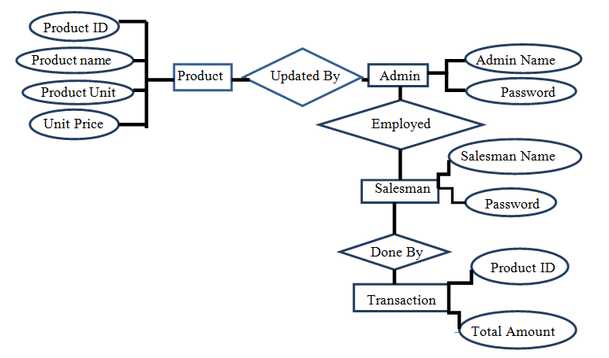**Figure 1: E-R Diagram**

The E-R diagram presented is for the inventorydatabase and transaction.

4

**5. Description of the Total System**

The Department Store Management System is divided into following parts:

1. Database

2. Inventory Management System

3. Billing System

1. **Database**: The database stores the inventory records. The inventory includes product information such as product ID, name, unit etc. It maintains the record of admins and their login password as well as the salesman’s.

2. **Inventory Management System**:This system includes tools for entering and updating the records in the inventory. The task is done by inventory manager. This system automatically updates the inventory after the sale of any product.

3. **Billing System**:The billing system creates and prints the invoice after product entry at the Point of Sale(POS) by the salesman. The salesman can enter the product by the product ID. The invoice number, date, price of the specific product, total cost will be automatically generated and calculated. After the completion of product entry, the invoice will be noted in a PDF file which can be printed in a standard format from a printer interfaced with the computers.

As soon as the application is started, user login window is displayed. The employee will enter his/her user ID and password in his particular section after which the system will open the particular application window. Suppose the employee is salesman then billing system will start. The admin can access the billing and inventory management system. The admin also manages the salesman’s information section.

5

**6.Technical Description**

This project is widely based on database management system which includes accessing, adding, and modifying the contents of database. The system also prints the invoice after billing process which is accomplished using appropriate java application programming interface (API).

|  |
| --- |
| `  **S.N. Tools/Language/Software Purpose** |
| 1. Eclipse Java Interface for Programming |
| 2. JDK 7 Update 15 Development kit |
| 3. Java Programming Language |
| 4. Microsoft Windows 7 OS for Development & Testing |
| 5. Foxit Reader Documentation |
| 6. MySQL Database Tool |

**Table 6.1: Project Tools**

6

**7. Interfaces**

**7.1 Store Window:**

At first there is a window which is named **Store Window** where the additional store pic will be added. This window will be opened for only 2 sec.

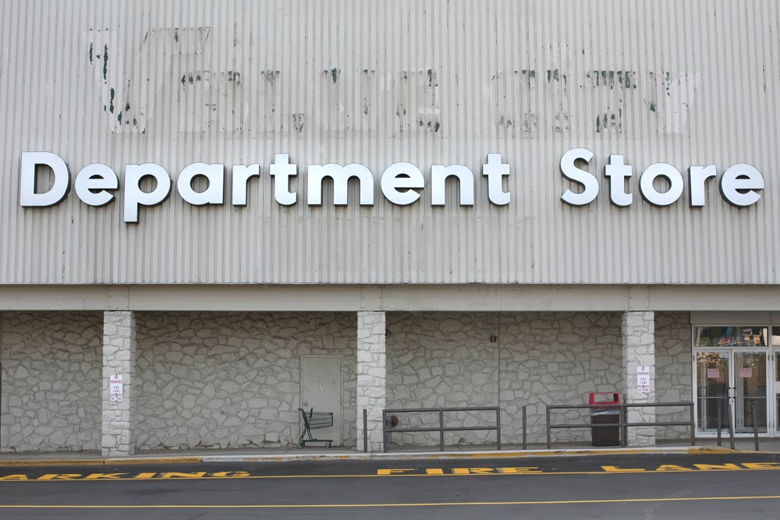

**Figure 7.1: Store Window**

7

**7.2 Entrance Window:**

The**Entrance Window** will show the employee their entrance window. Here is two different entrance button, one for Admin and another for Salesman.

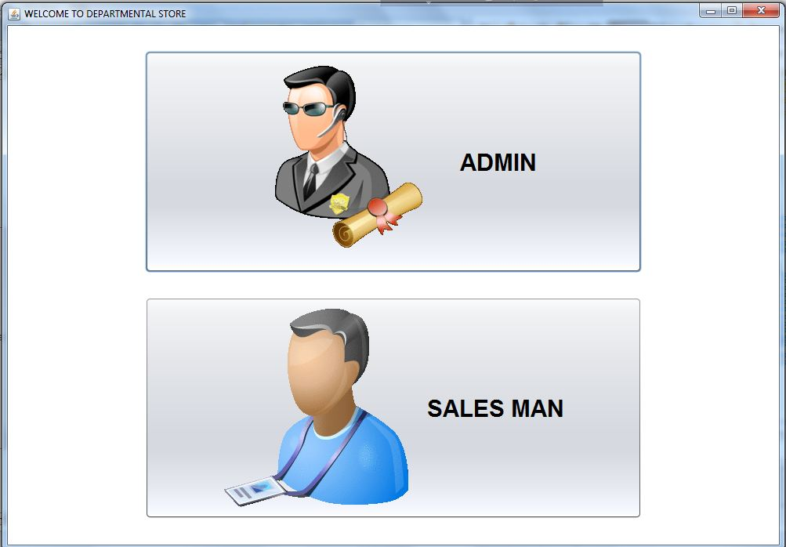

**Figure 7.2 Entrance Window**

8

**7.3 Admin Entrance:**

**Admin Entrance** window will required Admin name and password to enter. Valid Admin will be allowed to log in.

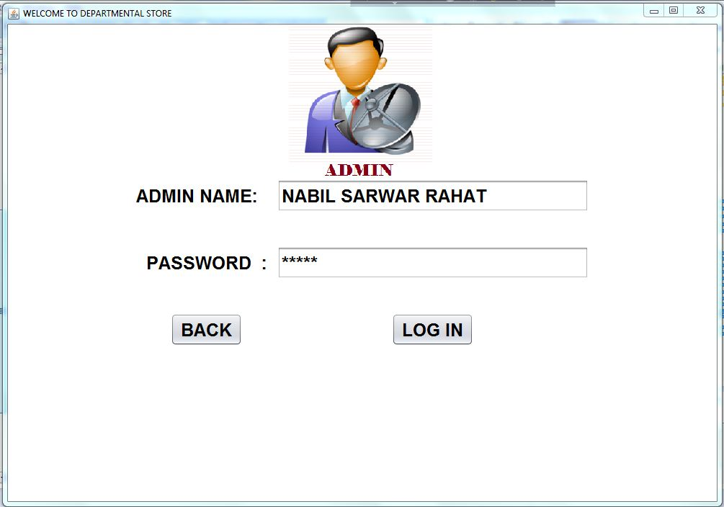

**Figure 7.3.1 Admin Entrance**

Invalid log in will not be granted.

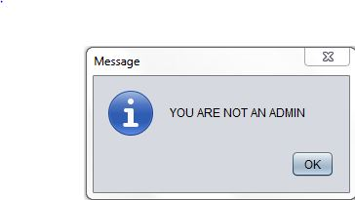

**Figure 7.3.2 Invalid Entrance**

9

**7.4Admin Panel:**

Here is the **Admin Panel**.The admin is able to do all essential works to done here. Admin can add,delete,update & search product. Salesman’s all info can be optimized and updated here.

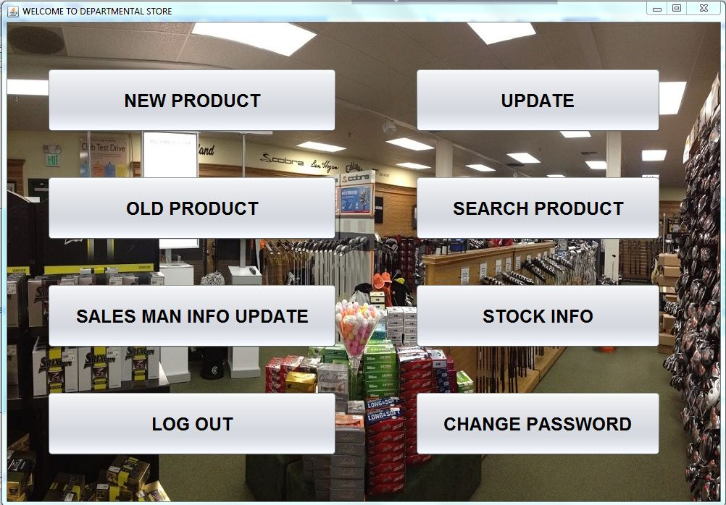

**Figure 7.4 Admin Panel**

10

**7.5Insert Panel:**

Admin can insert new product info through this panel. Product info can be updated through giving ID, NAME, UNIT& PRICE. Admin can also go to back window by clicking BACK button.

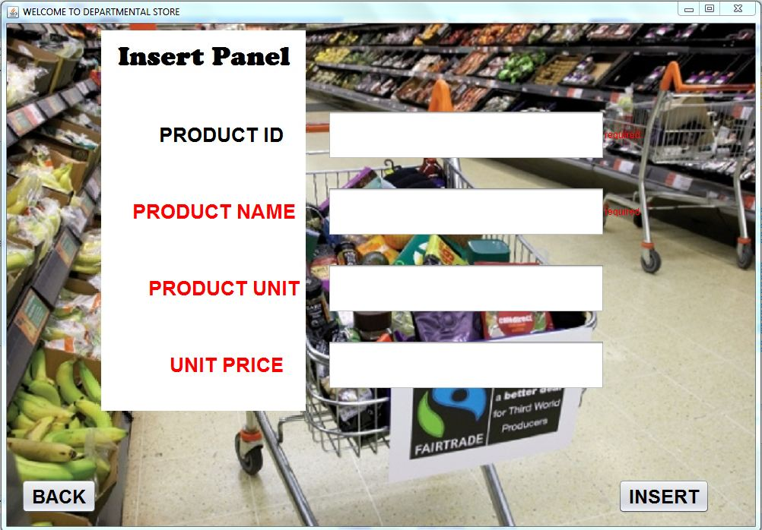

**Figure 7.5.1 Insert Panel**

After a successful insertion a massage will be shown.

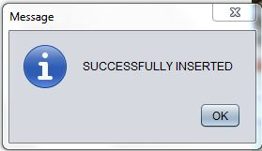

**Figure 7.5.2 Insert Massage**

11

**7.6Update Panel:**

In **Update Panel** Admin can update product ID, PRICE, UNIT, NAME by giving current ID. There is a CURRENT STOCK button where Admin can get the current amount of the desired product to update. Admin also can individually update product info such as only ID or UNIT.

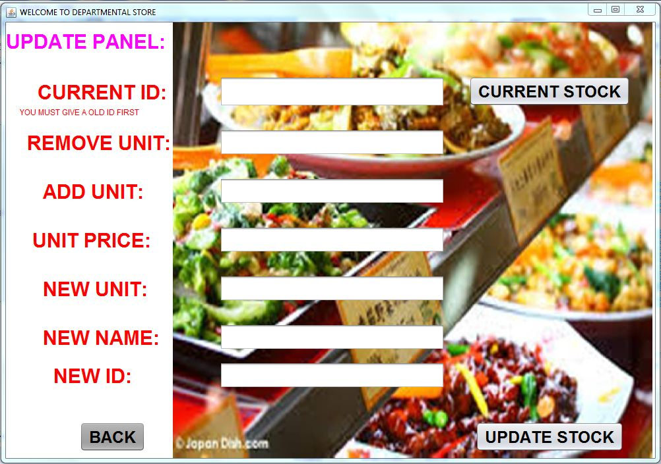

**Figure 7.6.1 Update Panel**

After updating any info there will be a related update completing massage.

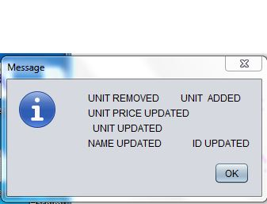

**Figure 7.6.2 Update Massage**

12

**7.7Delete Product:**

Product can be deleted by giving ID here. After inserting ID in additional box, automatically current product info will be shown there.

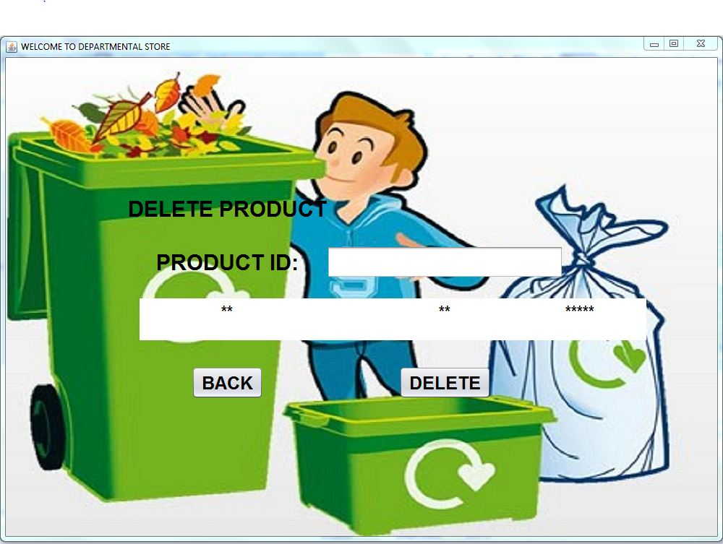

**Figure 7.7.1 Delete Product**

Successful Deletion will be shown through massage.

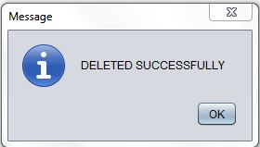

**Figure 7.7.2 Delete Massage**

13

**7.8Search Product:**

Here admin can search product through those Name, ID and Date. After insert any of these the total info about the desired product will be shown here.

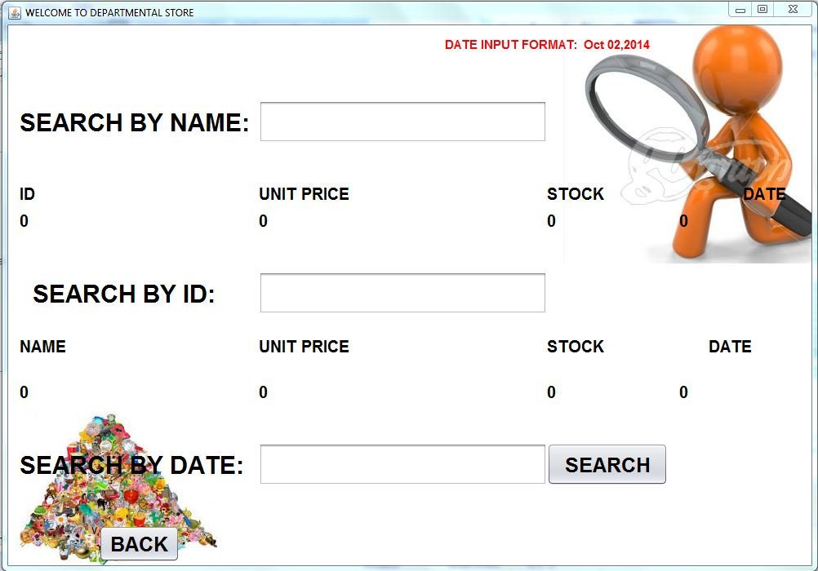

**Figure 7.8 Delete Product**

While search date there will be created a pdf file which will contain desired info.

14

**7.9 Salesman Info:**

This is the window where Admin will employ new salesman as well as delete their info. By giving Name, Id & Password a new salesman can be employed. Salesman can be deleted through giving their Id.

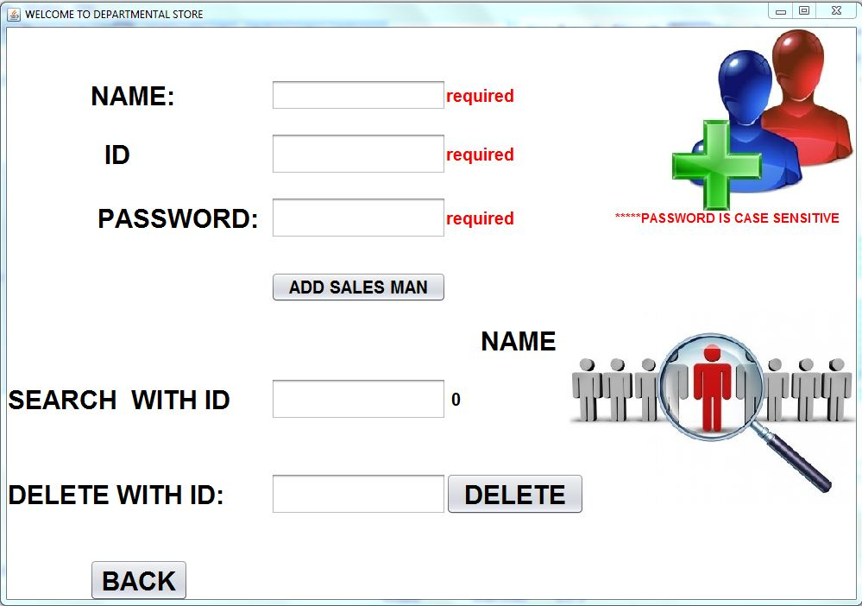

**Figure 7.9 Salesman Info**

15

**7.10 Whole Stock Info:**

The total stock info of the store can be known through this window. The total info will be shown in a generated pdf file. Specific product info can alsobe found by giving product ID in specified insert boxes.

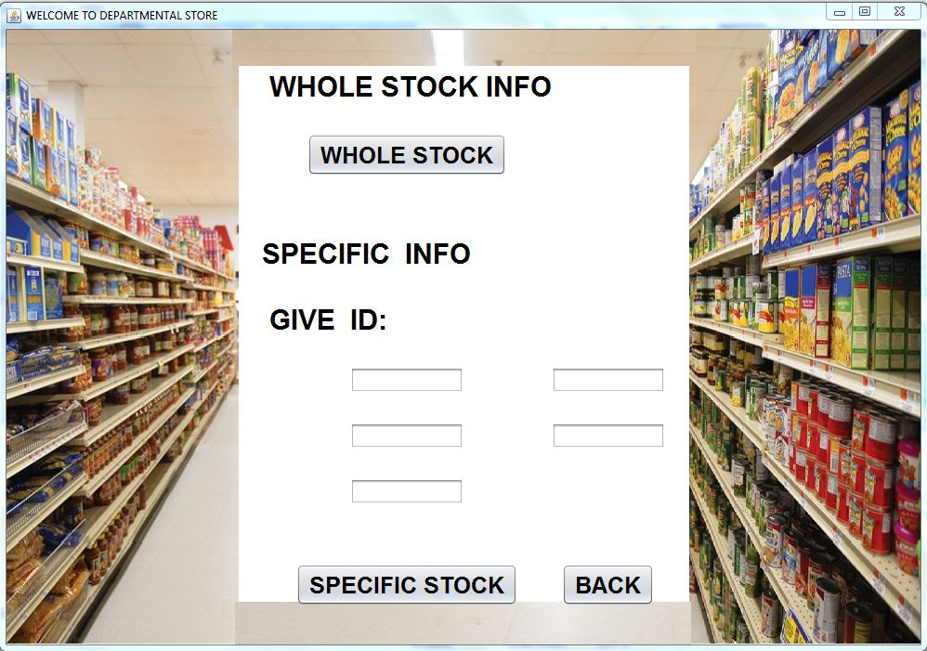

**Figure 7.10 Whole Product Info**

16

**7.11 Change Password:**

Admin can change own password through this window. Admin will need to give old password first to change password. Here Admin can also update salesman’s password by giving desired salesman’s ID and new password.

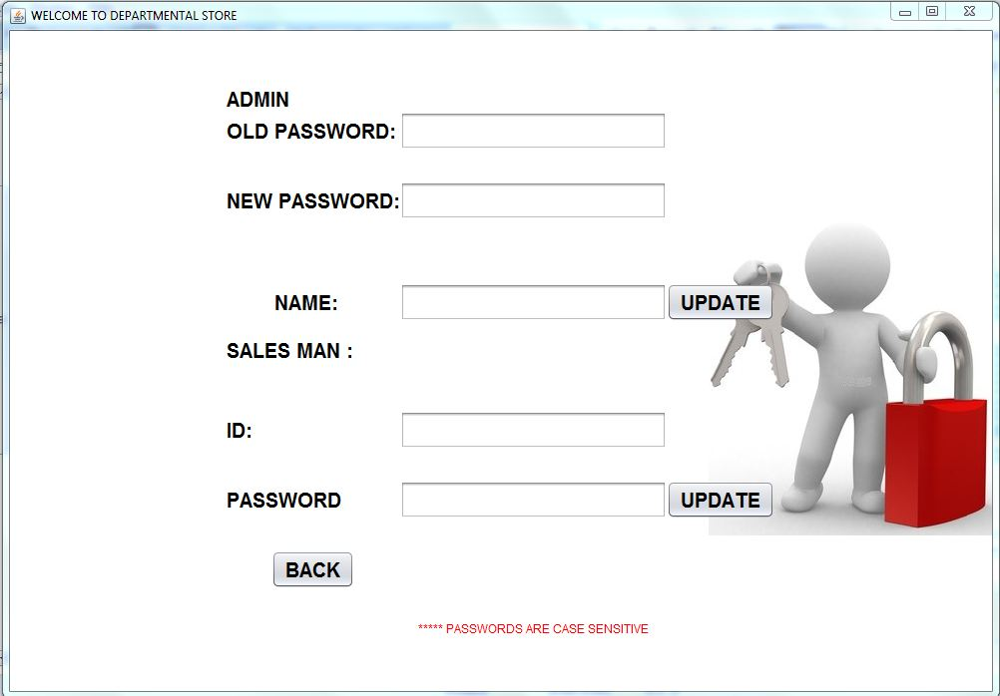

**Figure 7.11 Change Password**

17**7.12 Salesman Entrance:**

**Salesman Entrance** window will be shown after clicking the salesman button in **Entrance Window**. Authorized salesmen can log in via giving their NAME & PASSWARD. Only allowed salesmen can pass this window.

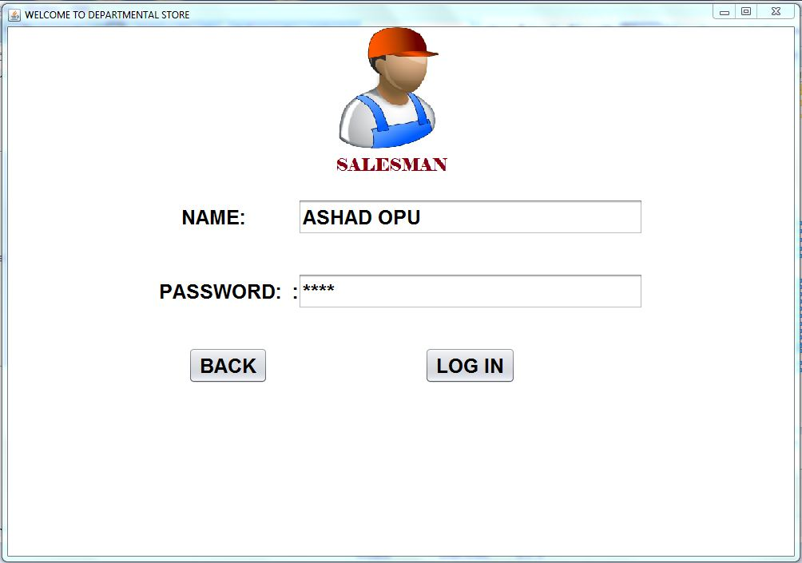

**Figure 7.12 Salesman Entrance**

18

**7.13 Salesman’s Workplace:**

In this window salesmen will perform their job. They will give the product ID to sell a product. After entering the desired ID, the product name, stock& unit price will be shown automatically. After entering the product quantity the total price will appear similarly. Then after clicking SELL PRODUCT button total transaction will be completed. After pressing the CASH MEMO button a cash memo will be created as a pdf file and then it can be printed.

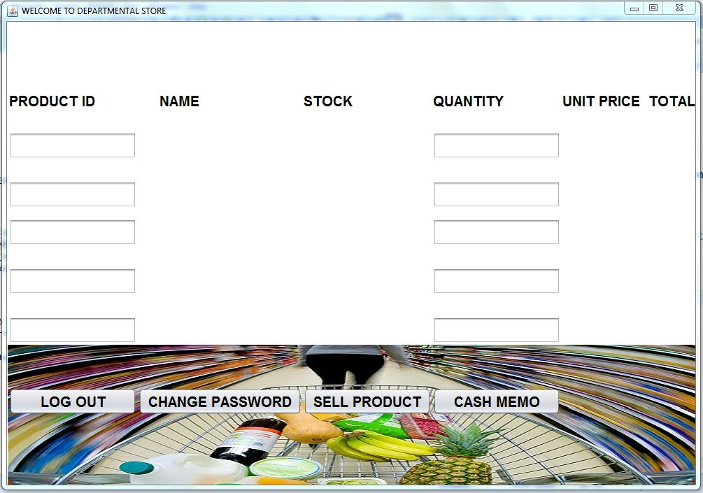

**Figure 7.13.1 Salesman’s Workplace**

Salesmen can also change their own password in this window. Here is a CHANGE PASSWARD button. Clicking this button change password window will appear. They can change their password by entering their current & new password as well as name.

19

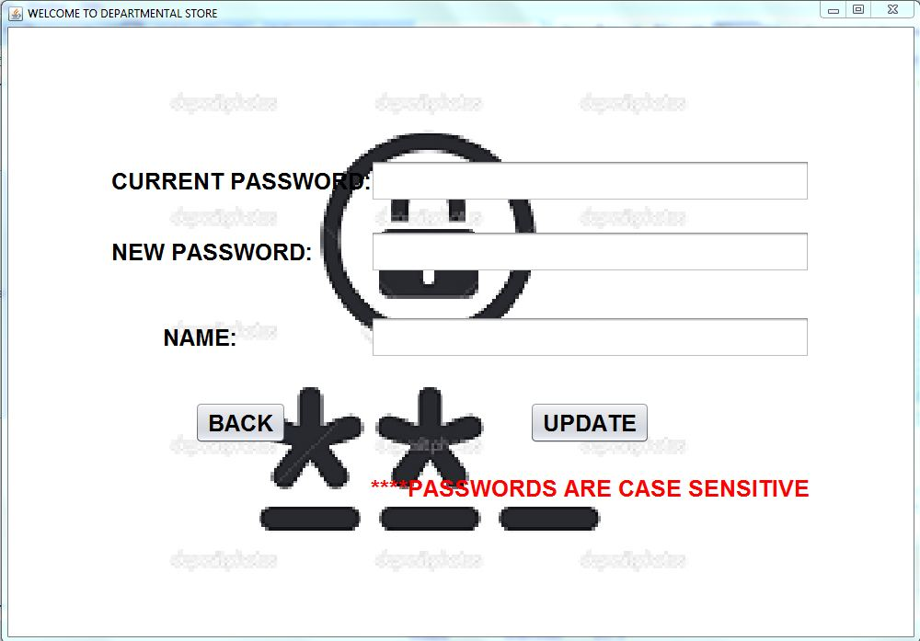

**Figure 7.13.2 Change Password**

20

**8. Cost Estimation**

|  |
| --- |
| **S.N. Purpose Amount(Tk.)**   1. Salary(Tk.15000/ mth * 3 persons) 45,000/- 2. Electricity Cost 3,000/- 3. Printing & Documentations 2,000/- 4. Genuine Software licenses 50,000/- 5. Miscellaneous Cost 10,000/-   Total 1,10,000/- |

**Table 8.1: Cost Estimation Table**

21

**9. Conclusion**

In the end, we succeeded to make a simple yet effective Management System to manage the activities of Departmental Store. We have to achieve this project by applying the knowledge of database and JAVA languages correctly. We have gained a valuable experience while learning to work as an effective team and completed the task in the given deadline. We intend to enhance this software by adding many other features and capabilities in future.

22

**10. References**

1. Java: How to Program by Paul Deitel and Harvey Deitel.
2. Linda.com

23